**RISC-V Class Project Phase 8 – MEMCTL Design**

This document provides an actual design for the MEMCTL function.

1. **Codasip Code**

Figure 1 Show a working version of the code for the ex_memctl() block. This is a state machine with r_me_memcnt as the state register, r_ex_memop as the control input and some registers to save various values. Note that you will need to assert s_ex_stall if s_ex_resp indicates a WAIT.

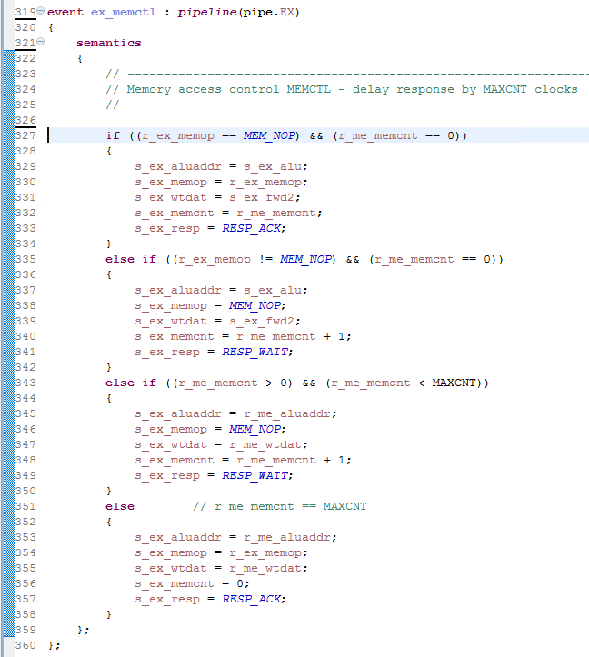

Figure 1

1. **Other Modifications**

Add any necessary signals and registers to the ca_resources.codal file.

Note that some signals may have different names than in your design. Use your schematics to update the ex_memctl() code.